Versions

Version | Date | Modifications | Author
1.0 | 07/08/2015 | Create document | MDE
1.1 | 04/02/2018 | Additions after actual install | MDE

Contents
2. Preface 3
3. Prerequisites 4
3.1. Hardware 4
3.2. Software 4
3.3. Other 4
3.4. Make a bootable USB 4
4. Installation procedure 6
5. Post Installation Steps 16
5.1. Packages 16
5.2. SSH 16
5.3. Network Interfaces 16
5.4. LEMP Webserver 18
5.5. FSTAB 28
5.6. SAMBA 29
5.7. Deluge 29
5.8. SickRage 29
5.9. VNC 29
6. Configure Telenet Router 30

- Preface

This guide is a combination of previously attempted tries to set up a home server and a little bit of knowledge. Now some of you can use it to your advantage.
- Prerequisites
  - Hardware

This part is somewhat loosely defined.
You can use an old computer (as I did at first), you can in fact buy a 10K server of a high end company. Or you can use, as I did, a Barebone/HTPC combination.
Because this setup is small (150x150), you can choose some components to your liking and you can mount it on the wall. You can go even further and find a barebone where you have to buy a processor as well, but hey, this isn’t a hardware course.

Components I used for my setup:

Component | Price
Intel NUC DN2820FYKH (LINK) | 141€
8GB Corsair RAM 1333Mhz 1,35V Single Channel (LINK) | 51€
Second hand 2,5” 500GB internal HDD | 20€
2x Toshiba Canvio Basic 2TB (as storage) / already had 1, bought a second one (LINK) | 86€
 | 298€
  - Software

In this guide, we will install ubuntu server edition 14.04.3.
Why an older version?
Because it has support until April 2019!
http://www.ubuntu.com/download/alternative-downloads

unetbootin version 584 (latest version – LINK)
  - Other

USB drive of 8GB (for booting the installer)

Screen / Mouse / Keyboard
I have to say, Intel NUC only has HDMI so no VGA screen will work. Simplest thing to do is connect it to your TV until the SSH is setup. As of then you can connect with your laptop and do not need an additional screen anymore.

  - Make a bootable USB

Start the unetbootin and select following settings:

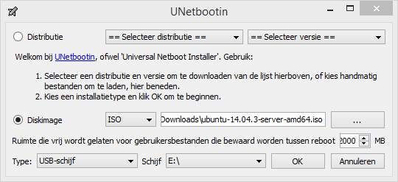
OK

Wait for it to finish.
Now you have a bootable USB stick with this content:

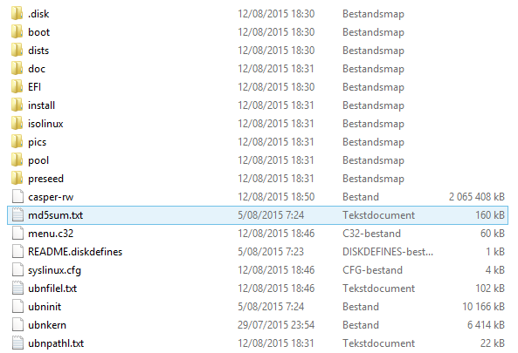

- Installation procedure

Take your newly created USB drive and plug it into a free slot on the server.
Make sure the keyboard, mouse & screen are already attached as well.
Attach a network cable, linux has the tendency not to work out of the box with WiFi.

These images are taken with a camera because, well, I had not time to configure taking screenshots during install.

Select in you bootloader to load from USB:

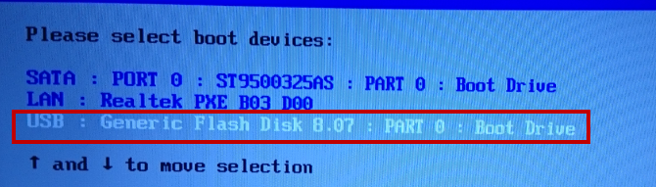

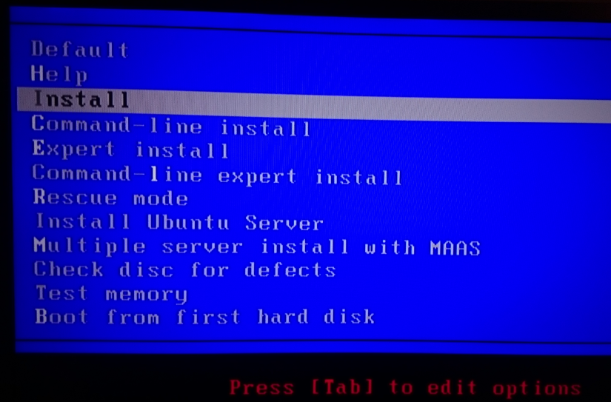
Be fast to select, you only have 10 seconds to move your cursor. Install.

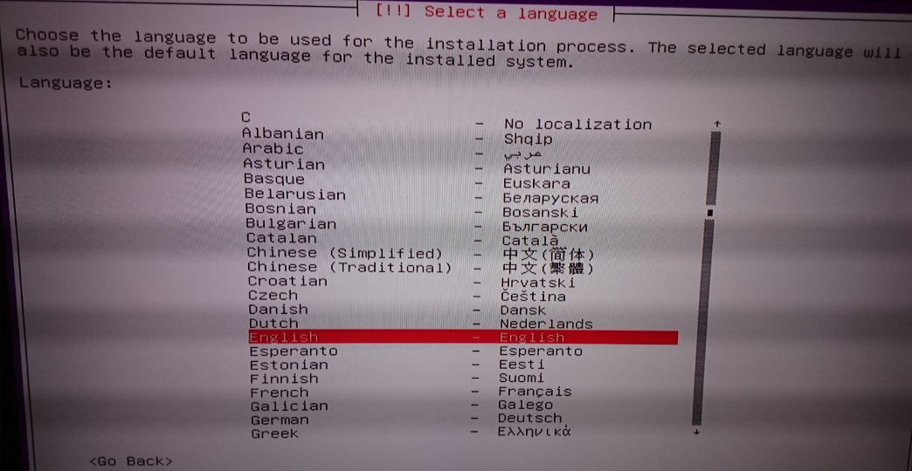
English

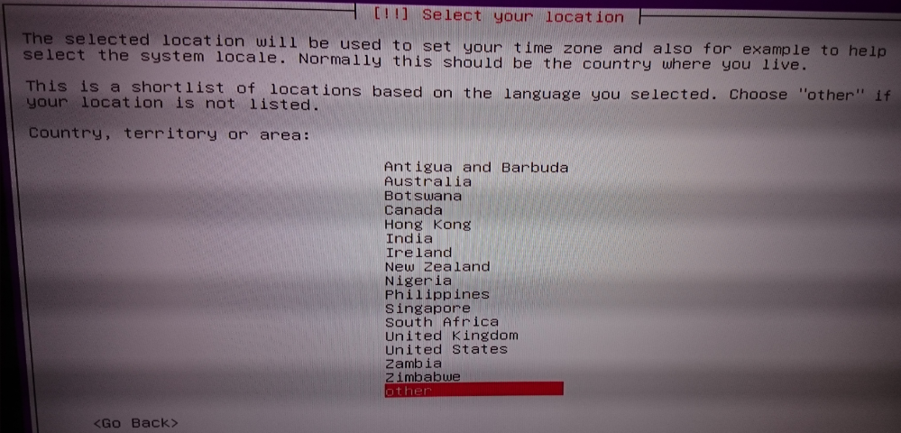
Other
Europe

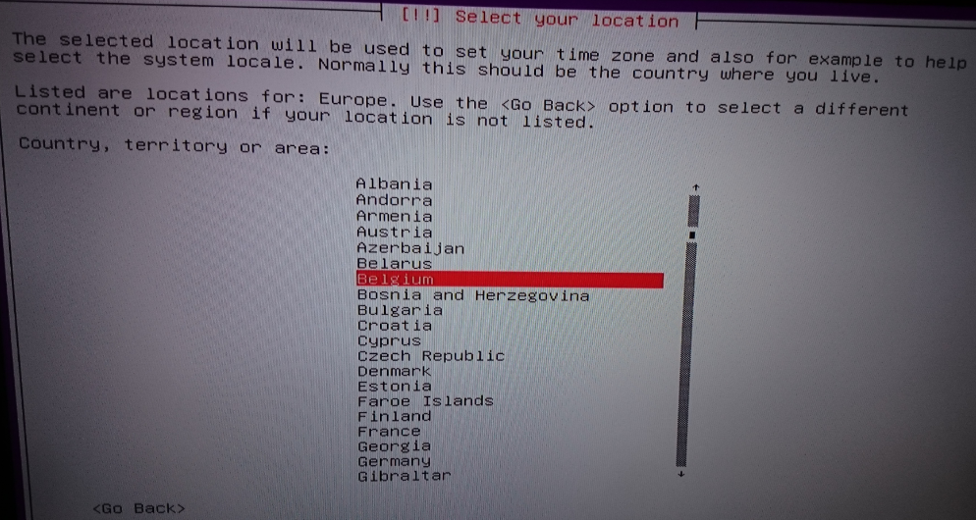
Belgium

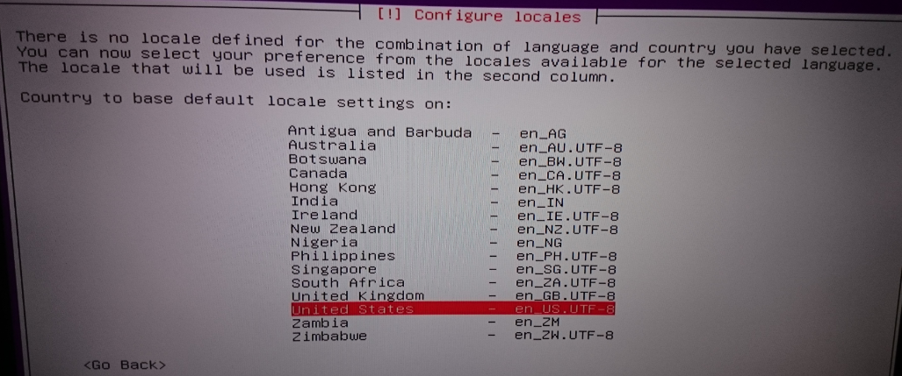
en_US

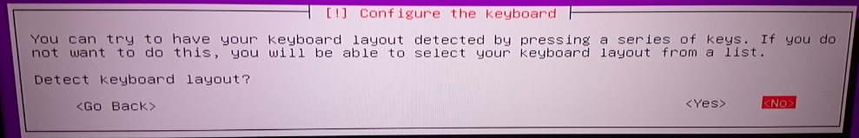
No

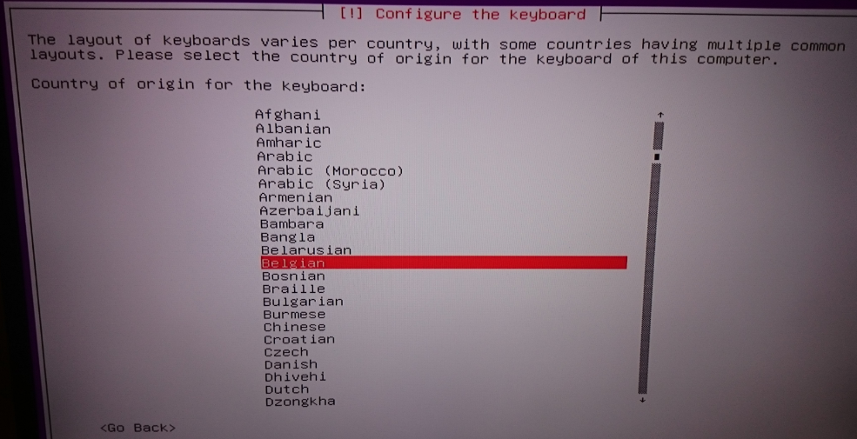
Belgian

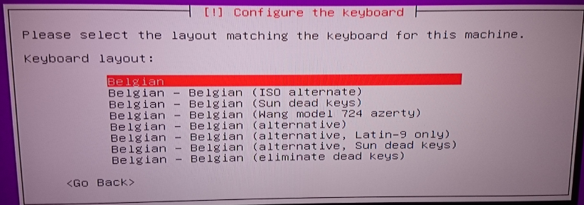
Belgian

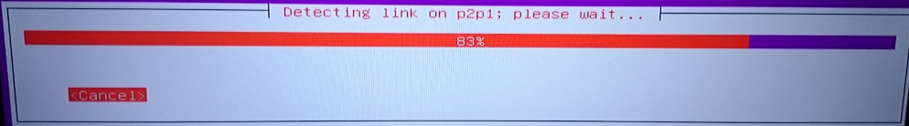
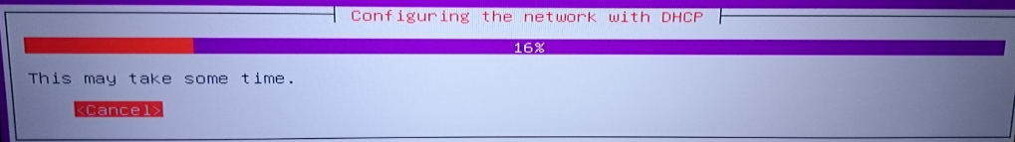

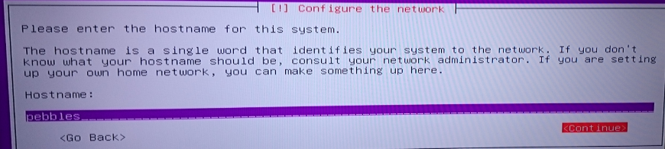
Choose the hostname (computername)

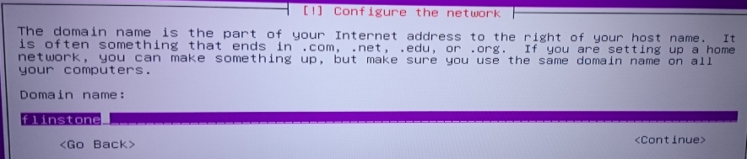
Choose a fictive domain (you can select WORKGROUP if you like, then it shows in windows network I think / not tested).

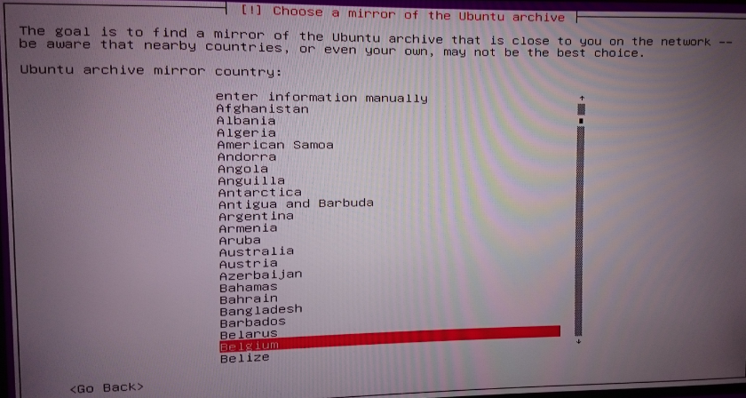
To download the latest updates for installation. Select Belgium.

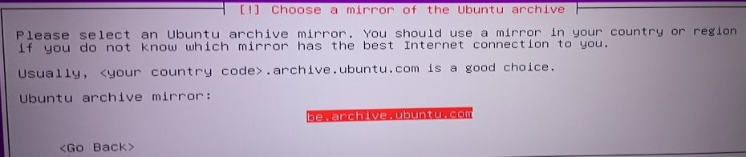
There is only one.

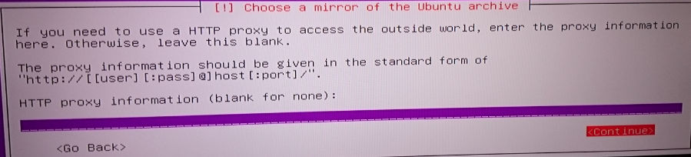
Leave empty. Continue

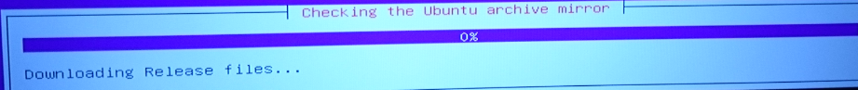
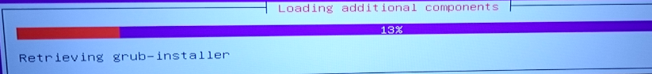

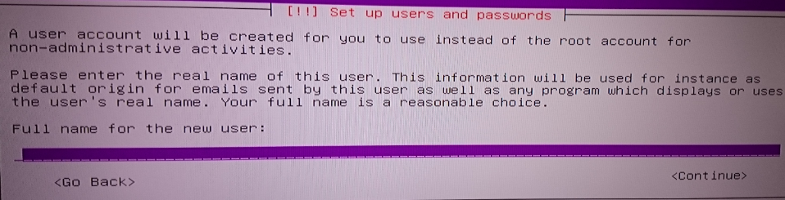
Fill out your full name.

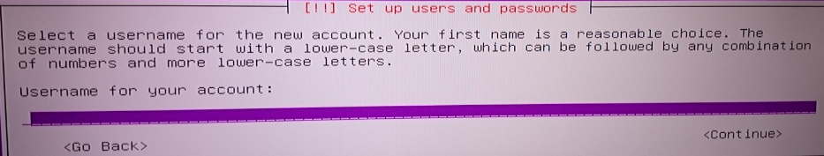
Fill out your username (to log on).

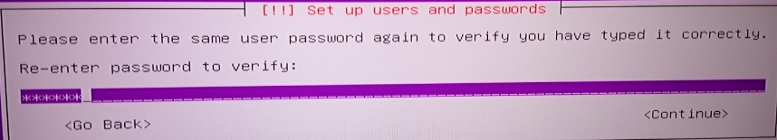
Type password (2x).

In case of:

Ignore.

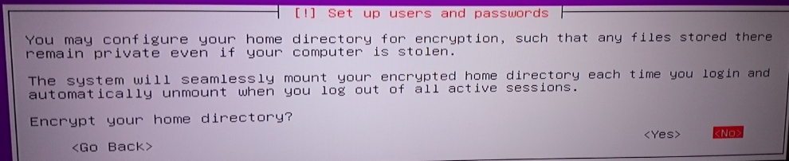
NO.

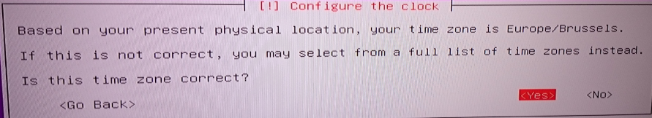
Yes

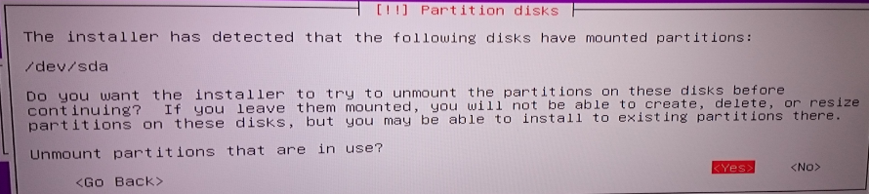
Yes

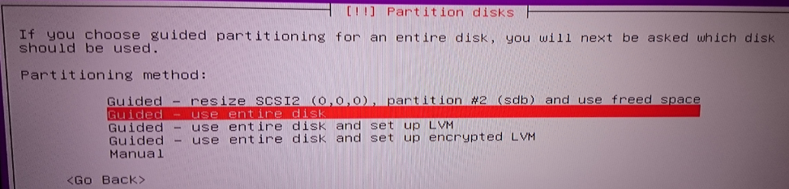
Use entire disk

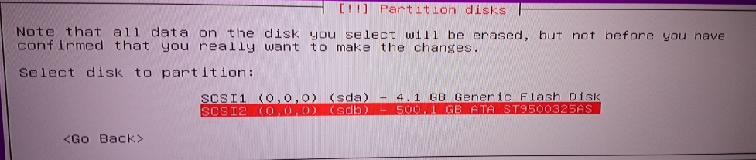
Select the correct one. Your USB drive is also a drive.
Normally it’s the largest you need.

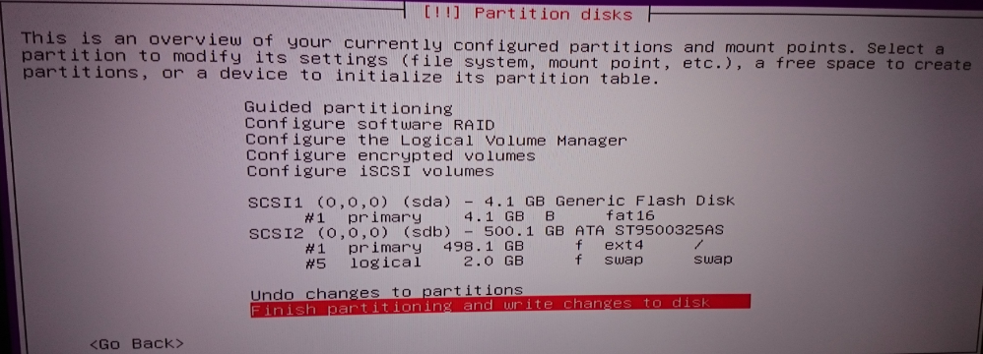
Setup automatically adds swap space as well. I have no problem with this. Select bottom line. ENTER.
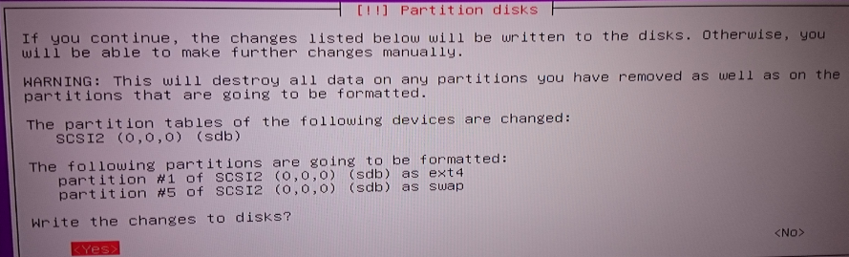
YES

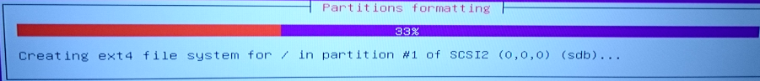
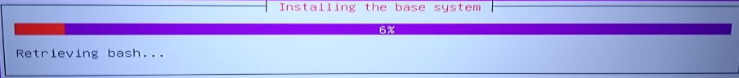
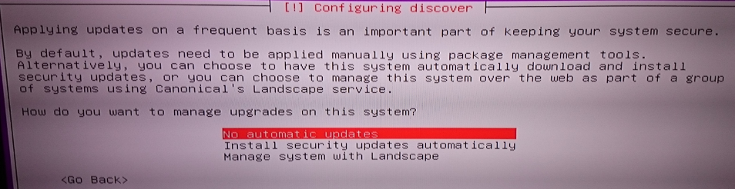
No automatic updates.

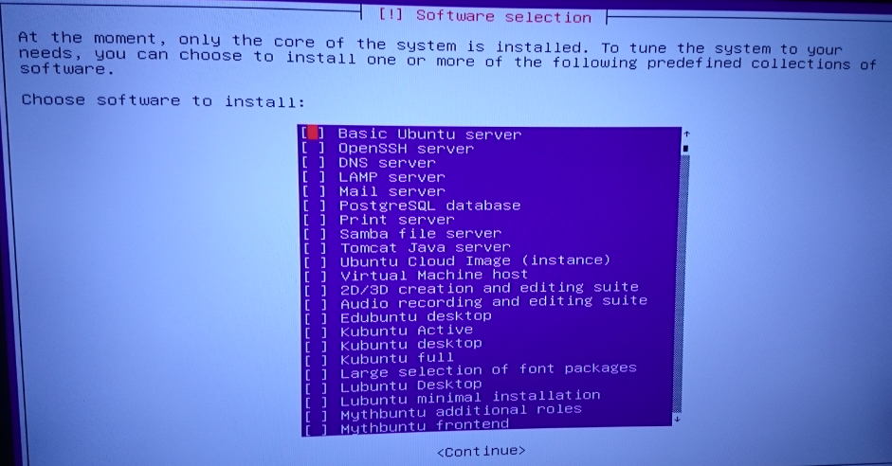
At this point you can select some packages the installer will install immediately in this setup. If you like some packages, select with SPACE, NOT ENTER. If you are done, press ENTER. I did not choose anything, everything you need is in the rest of this guide.

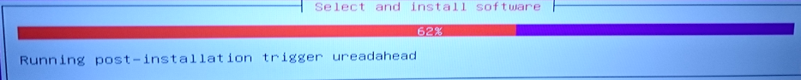
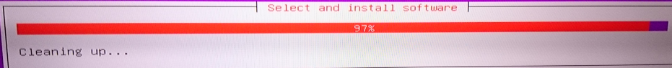
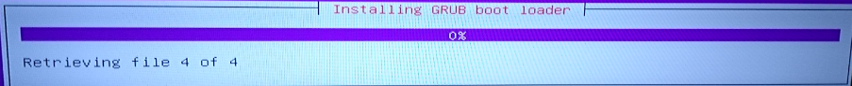

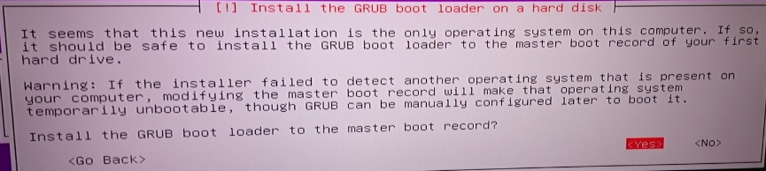
NO

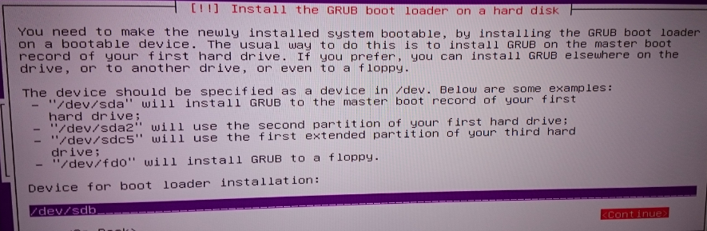
Type the drive you installed the system on. In my case it was /dev/sdb and not sda. Previous step would have done faulty!

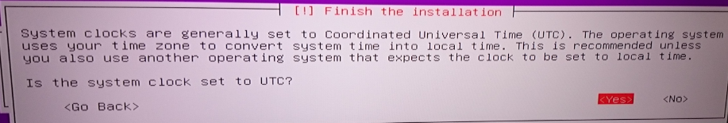
Yes

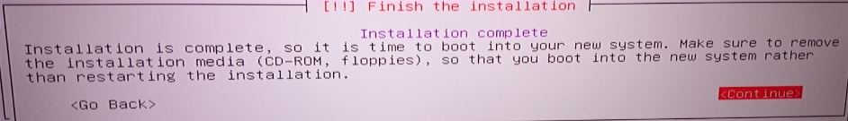
Remove the pendrive. Continue.

You should see the boot sequence eventually ending in a logon screen:
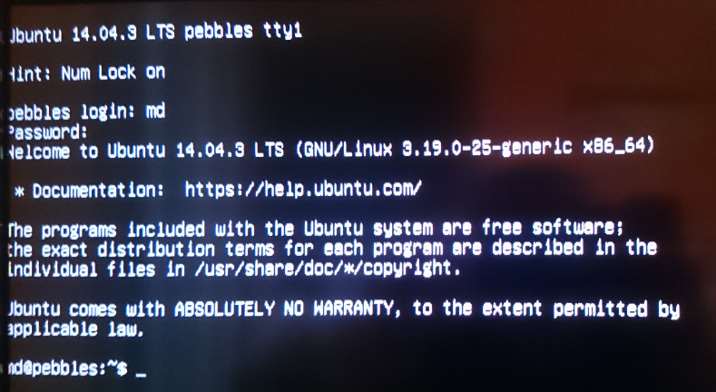
Use the user & passwd you created before.

You’re server is now ready to be used!!

- Post Installation Steps
  - Packages

Standard packages you will need for ease of use:

sudo apt-get install vim glances

In this chapter, it may be useful to know that I use vi for text editing. Some basic vi commands can be found here: http://www.cs.colostate.edu/helpdocs/vi.html . In any case, if you edit something and you are not sure, press escape and type :q! and ENTER.
  - SSH

SSH will be used in our setup for remote logon (command line & gui) + secure ftp.
Install openssh-server like this:

sudo apt-get install openssh-server

Click yes whenever needed.

We begin with the one that removes the screen, mouse and keyboard from the equation. Tell openssh to listen on 22, 2222 and 7777.

cd /etc/ssh/
vi sshd_config

find the line “# What ports, IPs and protocols we listen for”
press i and add these lines:

Press escape, type :x and ENTER.

Now restart the service with command:

sudo service sshd restart

It should restart right away. You can now connect to your server with another machine (linux command line or putty through windows).
  - Network Interfaces

The last thing you want is to have a server with DHCP. Every time you restart you have the risk of ending up with a new IP. Which is not very convenient to connect to if the IP keeps bouncing around. So, we set a static IP for our server.

For this, go to the interface file and adapt it with VI like this:

cd /etc/network
vi interfaces

And it should look like this:
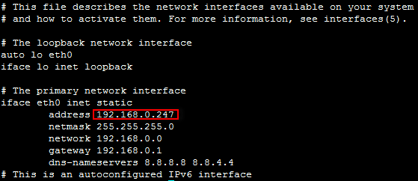

You can choose your own IP.
Extra info: https://help.ubuntu.com/lts/serverguide/network-configuration.html
Remark that dns-nameservers have to be specified or your internet connection will be lost at next reboot!

Restart the interface:

sudo ifdown eth0
sudo ifup eth0

Afterwards, type:

ifconfig

Should show you the IP you’ve choosen.

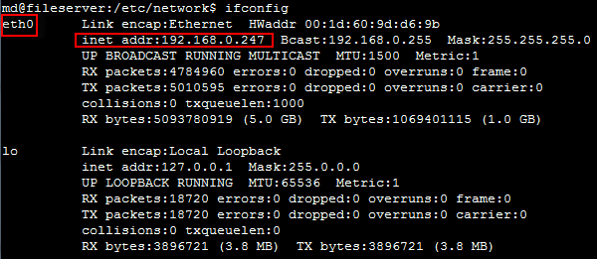

You can now disconnect the screen, mouse and keyboard. You can still use them if you want but it’s a bit weird to work on the TV

To connect from your laptop, download putty.exe from: http://www.chiark.greenend.org.uk/~sgtatham/putty/download.html

You do not have to install. Place it on your desktop and open.

Fill out the details like this:
Host Name = IP address you wrote down or the hostname (the one you choose in setup)
Port 22/2222/7777 are available
SSH
Saved sessions: type a name (home server) and save.

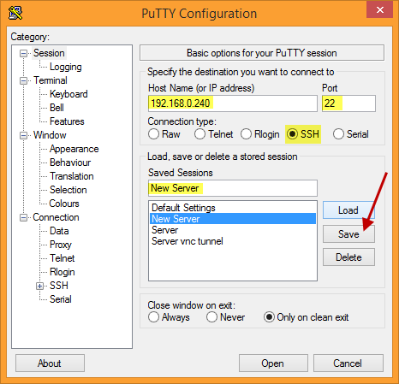

Press .
You will get a screen with login possibility like you had before on the server itself.

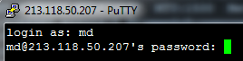 (you will not see the password, type and ENTER)

You are successfully logged onto your own server .

  - LEMP Webserver

See remark at the end of this chapter!
Followed this awesome guide (a little): https://www.digitalocean.com/community/tutorials/how-to-install-linux-nginx-mysql-php-lemp-stack-on-ubuntu-14-04

Create ssh keygen

ssh-keygen -t rsa

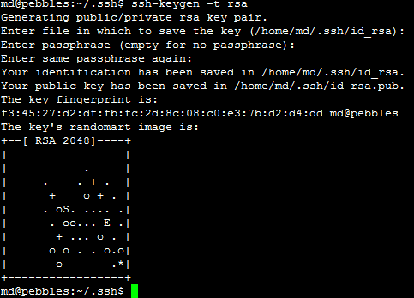

Install necessary software.

sudo apt-get install nginxmysql-server php5-fpm php5-mysql

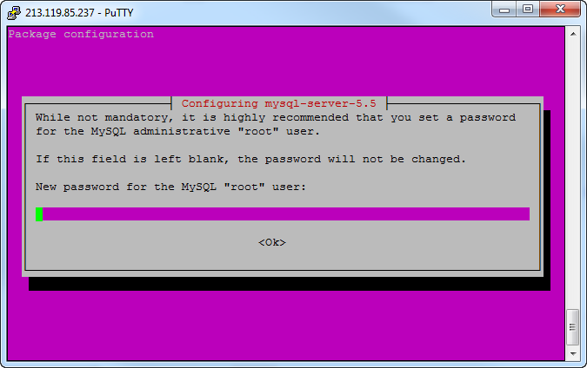

Choose the same password as your normal user… (you can take another but don’t forget)

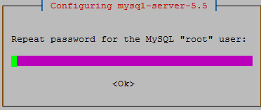

Wait for it to finish.

Now you should definitely be able to address your website on the server. From within your own network, type in the chrome/firefox/IE/opera/safari: http://<IPofyourserver>/ (in my case 192.168.0.240).

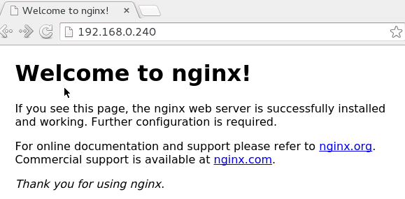

Now let’s configure some shit.

Do this commands to setup mysql database:

sudo mysql_install_db
sudo mysql_secure_installation

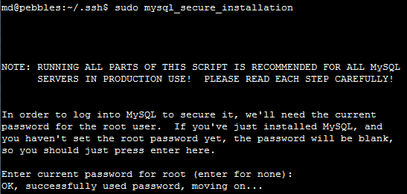
type root passwd

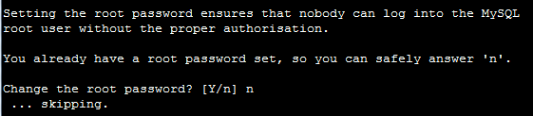
N + enter

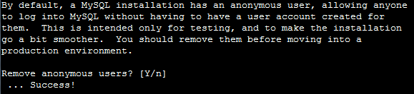
Y + Enter

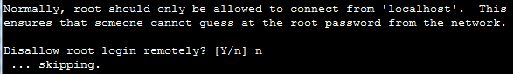
N + enter

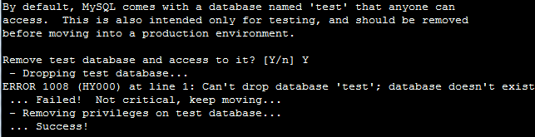
Y + enter

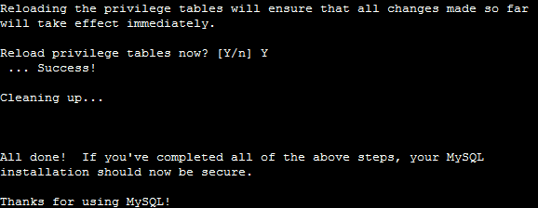
Y + enter
Done.

Configure PHP

sudo vi /etc/php5/fpm/php.ini

find the correct line by typing:

/;cgi.fix_pathinfo=1

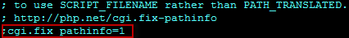

Change (type i) to

Save (type :x).
Restart the php service:

sudo service php5-fpm restart

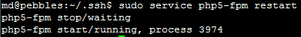

Configure NGINX

sudo vi /etc/nginx/sites-available/default

To start, as we are behind a telenet router we will not be able to port forward port 80 (and everything below 1024) to our server, and we cannot port forward a high port on the router to a lower port on the server. Identical ones do work, so to make things easy we pick port 8080. More info in chapter XX.

Change this
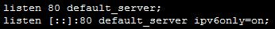
To this
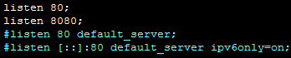
Our web server will listen on 8080.

We want to use php in our website so the main page it has to recognize is index.php. Add it to this line:

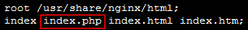

Enable and change the error page to 404.php:

Now the most important part is to get this right to enable php support, change this block:

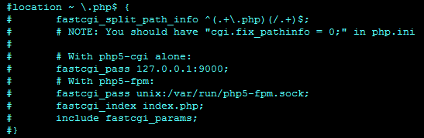

To

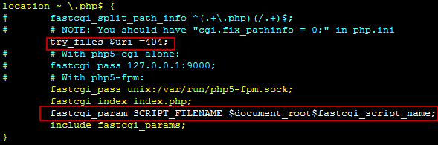
(yellow enable = remove the hashtag #, red = additional lines) (do not forget ; on each line and the closing ‘}’)

Save the file (:x) and restart nginx.

sudo service nginx restart

Now we will test this by creating a file info.php in folder /usr/share/nginx/html (document root remember)

sudo vi /usr/share/nginx/html/info.php

<?php
phpinfo();
?>

Is the content. Save (:x).

Try now to reach it through http://<yourserverIP>/info.php
And http://<yourserverIP>:8080/info.php

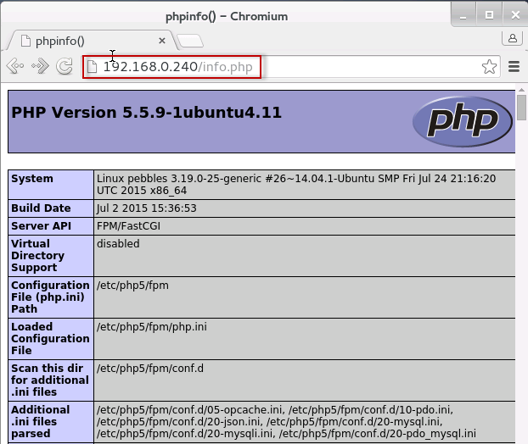

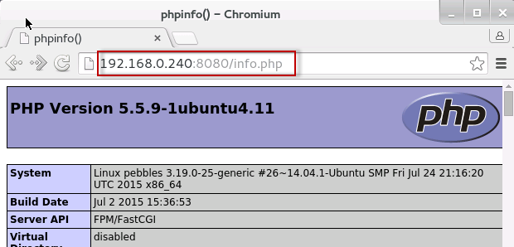

If you do not see this, you have my number.

Almost done, we would like to access our mysql database as well.

Therefore, install phpmyadmin:

sudo apt-get install phpmyadmin

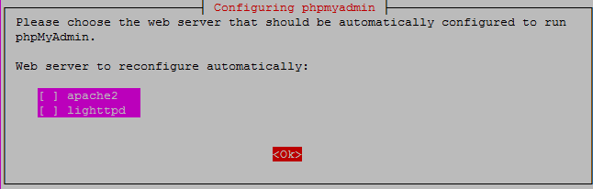
Select none

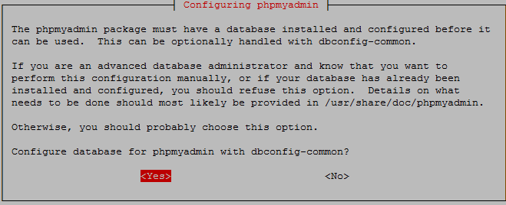
Yes

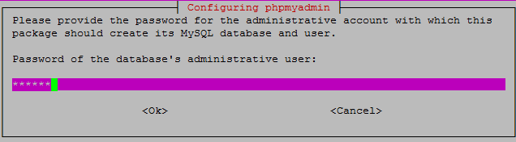
Same passwd as always

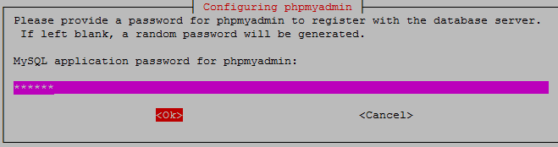
The same again
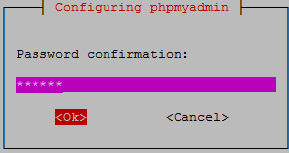
They just can’t get enough!

Now just include a symbolic link to mysql location so you can access your database through the mysql GUI.

sudo ln -s /usr/share/phpmyadmin/ /usr/share/nginx/html/phpmyadmin

Is the result.

You should be able to connect to your GUI through http://<yourserverIP>/phpmyadmin

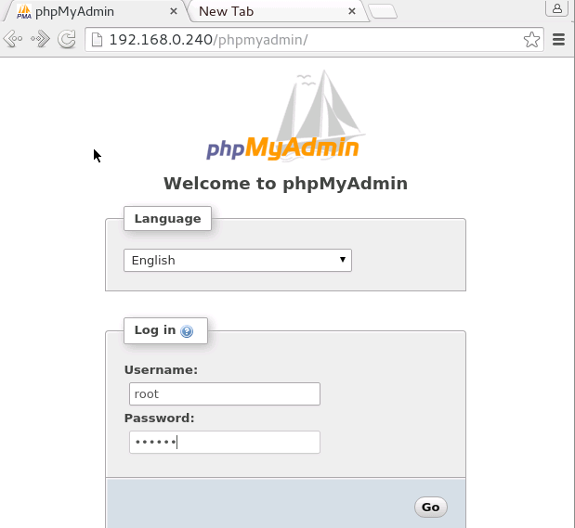

Login with root user and password (if you used the same passwd everywhere you’ll know which one…)

Note: to create another website on your server, copy the default profile, change the port & document root + add a symbolic link to /etc/nginx/sites-enabled

Configure SSL for NGINX

If you type https://<yourserverIP>/ you will notice it will not connect. SSL is not configured.

sudo mkdir /etc/nginx/ssl

Make your certificate:

sudo opensslreq -x509 -nodes -days 1095 -newkey rsa:1024 -keyout /etc/nginx/ssl/nginx.key -out /etc/nginx/ssl/nginx.crt

you can change days and ecryption length. Mine has 3 years + key length of 1024 which all recent (and not so recent) browsers can handle. Fill out the rest the best you can:

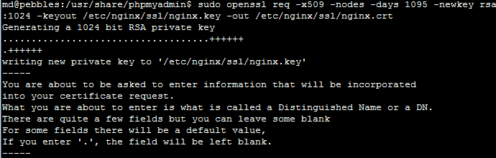
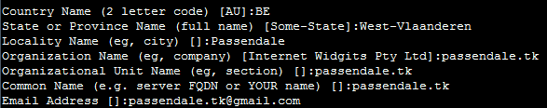

You can now see 1 certificate and 1 key in /etc/nginx/ssl

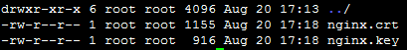

Now adapt the default website file again:

sudo vi /etc/nginx/sites-available/default

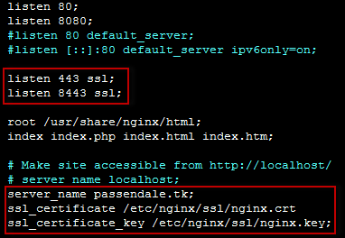
Make sure the server_name is the same as the Common Name in the certificate.
Restart the service:

sudo service nginx restart

Check by typing https://<yourserverIP>/ or https://<yourserverIP>:8443/ .
Now you can make a connection. It will say it is not allowed etc… go further.

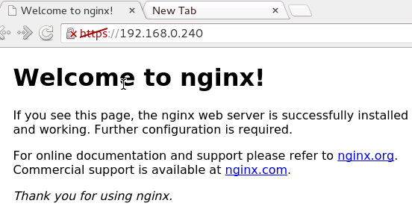

You have successfully made a secure connection to your website.

From now on you are on your own. Files you want to show on your website are located in: /usr/share/nginx/html/ .

Very good HTML & PHP & MYSQL guides onW3C Schools.

REMARK: I switched to LAMP after a while!!

https://www.digitalocean.com/community/tutorials/how-to-install-linux-apache-mysql-php-lamp-stack-on-ubuntu-16-04
Gevolgd door
https://www.digitalocean.com/community/tutorials/how-to-create-a-self-signed-ssl-certificate-for-apache-in-ubuntu-16-04
Extra info
http://blog.technerdservices.com/index.php/2015/04/creating-a-home-server-part-7-how-to-add-ssl-to-an-ubuntu-14-04-lamp-web-server/

  - FSTAB

FSTAB is not a program. It is a file that lets you automount drives at startup. Otherwise, as with internet interfaces the drives could be mounted in different order etc messing up your SAMBA shares. On the other hand, if the server is missing a drive at boot, it will NOT start the server!

Therefore, I wrote a script to automount all the connected drives. If the drive is not connected, it is not mounted. If the drive is not attached to server at boot time with FSTAB the server will not start!!

With the script, the server starts completely before mounting the drives, which is a far more graceful solution.

Below you can find the script. You still have to adapt it to the drives you want to mount off course.

#!/bin/bash
# declare all of your drives
DOCUMENTS=/dev/disk/by-uuid/843671A53671993E
SERIES=/dev/disk/by-uuid/1296835D96834069
# check if symlink for above drives exist and mount the drives to correct locations
if [ -e "$SERIES" ] && [ -b "$SERIES" ];
then
echo "mounting SERIES drive to /media/canvio/ ..."
mount -t ntfs-3g $SERIES /media/canvio
echo "$SERIES is a block device."
fi
if [ -e "$DOCUMENTS" ] && [ -b "$DOCUMENTS" ];
then
echo "mounting DOCUMENTEN DRIVE to /media/DOCUMENTS"
mount -t ntfs-3g $DOCUMENTS /media/DOCUMENTEN
echo "$DOCUMENTS is a block device."
fi
# created by Sn1peH4ll

First, write down the UUID of your drives and know which /dev/sdX equals which UUID.
You can do this by typing

sudo blkid

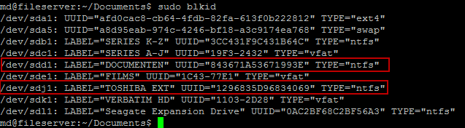

The ones in red are the ones I need, but they are currently on my old server and I need to rename the label of the latter to “SERIES”. We’ll work with these in the rest of the tutorial.

Now find out if the uuid is connected by typing

ls -l /dev/disk/by-uuid/

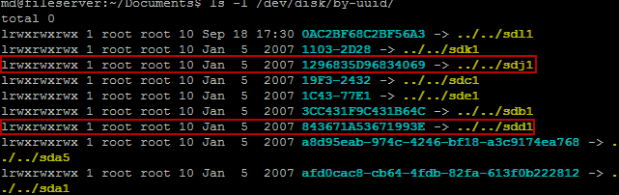

This gives you a list of uuid’s and to what /dev/sdX they are connected. You can clearly see they match with previous screenshot.

A simple command like this mounts the drive. All done by the uuid (unique identifier) of a drive.

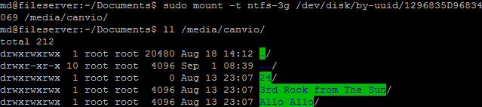

I use this information to build my script. First it checks if the UUID is connected to the server. If it is not, it is simply not mounted. If it is, the script will mount the drive.

In case you have to do it by hand.

sudo fdisk –u
sudo mount –t <type> /dev/sdX/ /media/<folder>

with type = ntfs-3g or vfat (format your drives ntfs please,much easier)
and sdX = the drive found with fdisk

Fill out this information into the script you saw before and place it somewhere on your server. The file shoud be created with sudo, have chmod 775.

Next login to the root account

sudo su

Type in your password if asked.

crontab -e

Add this line to the end of the file (with VIM which by now you should understand):

@reboot sh /home/<user>/scripts/automount.sh &

As this will be run as root, and in the background (&), we do not need to worry about the script asking for a password nor holding back the boot sequence.

Type:

exit

Now reboot to check and you shoud see your drives being automounted on /media/.

In case you did not notice, you have to create the mounting points in /media/

sudo mkdir /media/<name you want>

  - SAMBA

This chapter is only relevant if you want a drive that is accessible on your home network. I guess this is the point of setting up a home server, so should apply to everyone reading this I guess.

Best thing is it can be used in combination with openelec (Kodi, etc …) for streaming media to your home theater.

Start by installing samba:

sudo apt-get install samba

Settings used to make SMB shares work (maybe it is simpler than that 😊):

/etc/samba/smb.conf

#=== Global Settings ===#

[global]

workgroup = WORKGROUP
netbios name = pebbles
server string = %h server (Samba %v, Ubuntu)
dns proxy = no

log file = /var/log/samba/log.%m
max log size = 1000
syslog = 0
panic action = /usr/share/samba/panic-action %d

server role = standalone server
passdb backend = tdbsam
obey pam restrictions = yes

passwd program = /usr/bin/passwd %u
passwd chat = *Enter\snew\s*\spassword:* %n\n *Retype\snew\s*\spassword:* %n\n *password\supdated\ssuccessfully* .
pam password change = yes

map to guest = bad user

usershare allow guests = yes

#server min protocol = SMB2
#server max protocol = SMB3

#=== SHARES ===#

[SERVER DOWNLOADS]
path=/home/md/Downloads
available = yes
read only = no
browsable = yes
public = yes
writable = yes
guest ok = yes
guest account = nobody
force user = md
write list = md
create mask = 0777
directory mask = 0777
inherit permissions = yes

[DOCUMENTEN]
path=/media/DOCUMENTEN
available = yes
read only = no
browsable = yes
public = yes
writable = yes
guest ok = yes
guest account = nobody
force user = md
write list = md
create mask = 0777
directory mask = 0777
inherit permissions = yes

[SERIES]
path=/media/SERIES
available = yes
read only = no
browsable = yes
public = yes
writable = yes
guest ok = yes
guest account = nobody
force user = md
write list = md
create mask = 0777
directory mask = 0777
inherit permissions = yes

[FILMS]
path=/media/FILMS
available = yes
read only = no
browsable = yes
public = yes
writable = yes
guest ok = yes
guest account = nobody
force user = md
write list = md
create mask = 0777
directory mask = 0777
inherit permissions = yes

So I have 5 shares which I can see in windows by typing:

\\PEBBLES\<SHARE_NAME>\

  - Torrent server

This is the torrent client I used. You can use others but with this one you can install a webui, which means we can access it online to download torrents in 1 place. We can even do this if we are not at home, see chapter 6 for more information.

I installed Transmission Torrent Client which has a web interface on the server.
Followed this guide:

https://help.ubuntu.com/community/TransmissionHowTo

Change the logon settings in settings.json like this (make sure the deamon isn’t running!!):

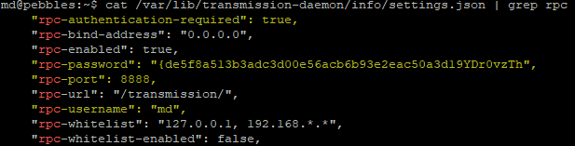
(for the password, fill out like you want, if you set “Ilovemymommy” it will hash it the next time you open the settings)

Try to logon:

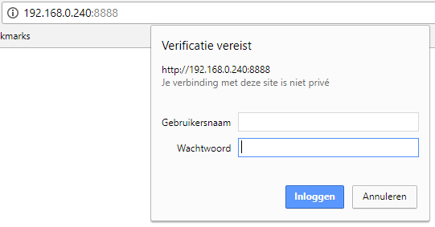

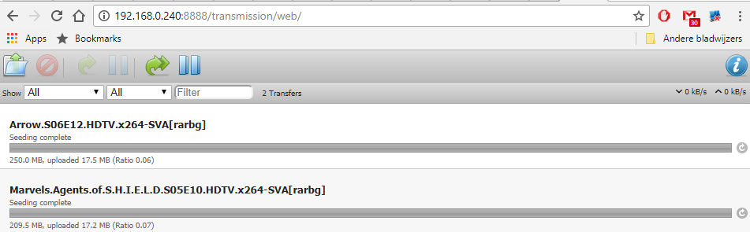

Settings (bottom of page):

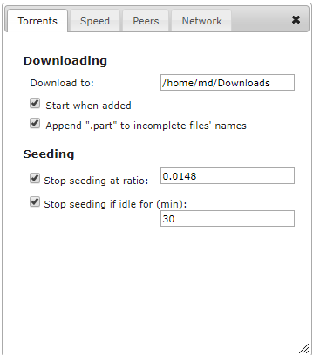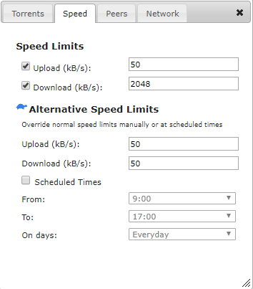

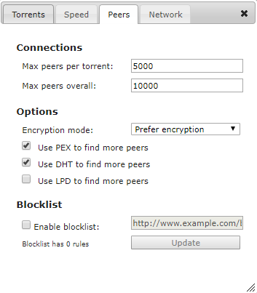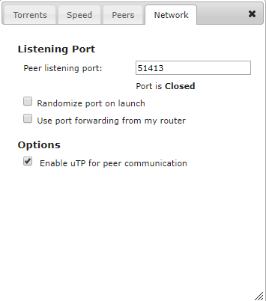

Afterwards I got a message trying to logon that it is an unsecure connection trying to logon from outside the home network.

Fix: https://forum.transmissionbt.com/viewtopic.php?t=14836

  - SickRage

This service is what you do it all for. It will keep track of all the tv shows you watch and whenever a new episode shows on TV, it will download it for you in the quality you want.

Installation

https://www.htpcguides.com/install-sickrage-ubuntu-14-04/
https://github.com/SickRage/SickRage/wiki/Sickrage-installation-Debian-Ubuntu-14-15-16

Configuration

First time you connect you don’t have to give up account & password.
You will see the landing page.

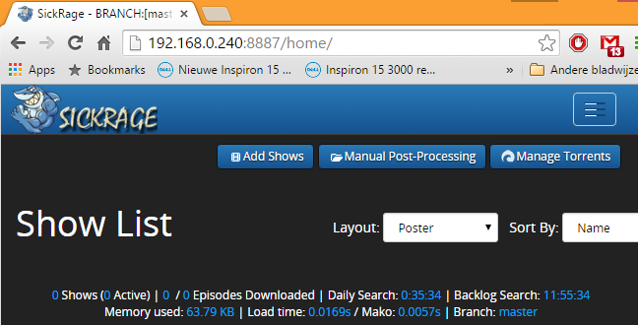

Now I will only list what I have changed. See for yourself what you want to change.

Go to settings > general > misc:

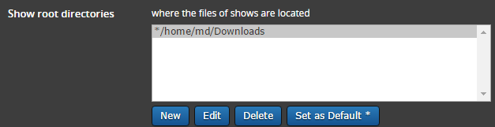
(if folder does not exist, create it)

Settings > general > interface:

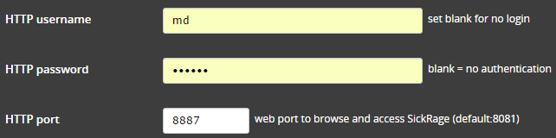

A username and pass can come in handy if you can access this port via internet. It’s just being safe.

Search Settings > Torrent search

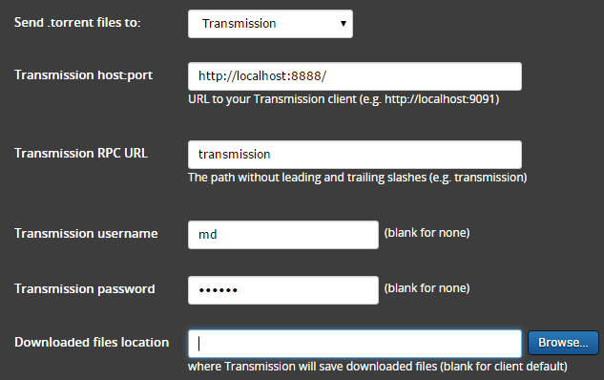

Search providers > provider priorities:

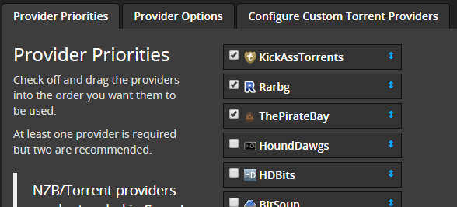

Provider options you can select settings for each provider:

Post Processing > Episode naming

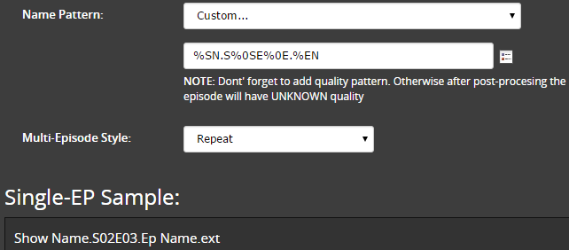

Add shows like this:

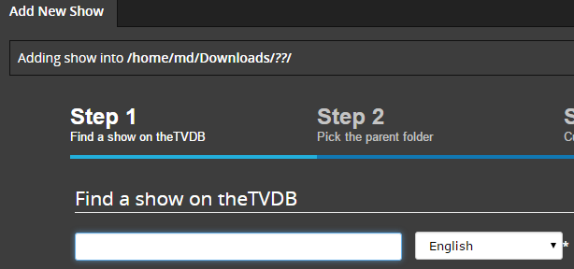

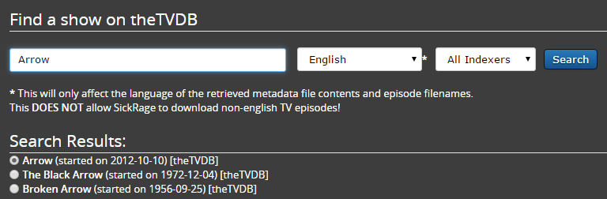

Next > Next

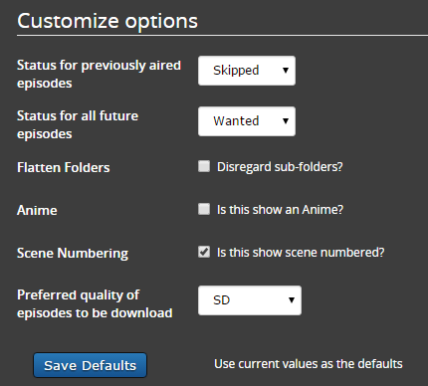

Save defaults.

Save.

Add other shows.
Done.
Wait till they come in.
  - VNC

Install vncserver.

sudo apt-get install vncserver

Start a windowed session by typing (with your user):

md@pebbles:~/.vnc$ vncserver :2

New 'X' desktop is pebbles:2

Starting applications specified in /home/md/.vnc/xstartup
Log file is /home/md/.vnc/pebbles:2.log

md@pebbles:~/.vnc$

It could be you still have to install a desktop environment (lxde, gnome, kde, xfce, …).
Google how to do it.

Install VNCviewer on your windows PC:

https://www.realvnc.com/en/connect/download/viewer/

Connect

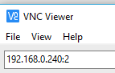

Give your password

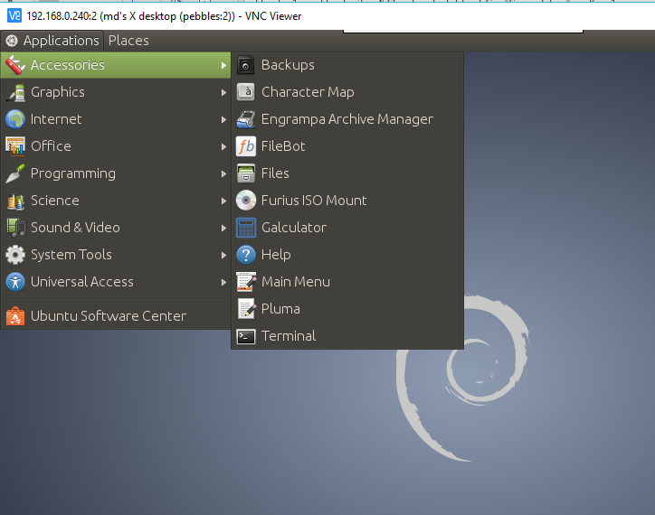

You can set the xserver session to start at startup (google that too for more info).

@reboot in crontab you can start vncserver :1

After startup is finished you can login with vncviewer.

  - Postfix (email)

Postfix can be used to send email from your server to somewhere else.

https://rtcamp.com/tutorials/linux/ubuntu-postfix-gmail-smtp/
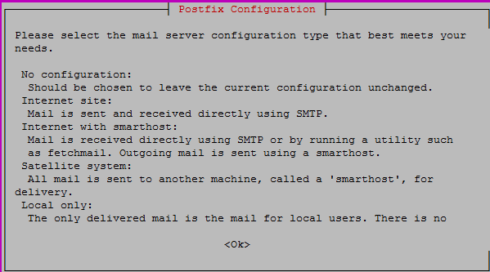
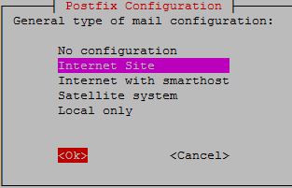
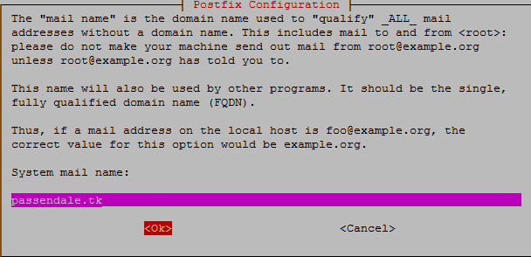

sudo vi /etc/postfix/main.cf

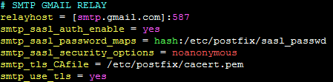
Comment out
Test
echo "Test mail from postfix" | mail -s "Test Postfix" dejonckheere.matthias@gmail.com
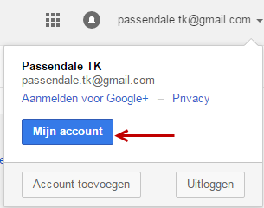
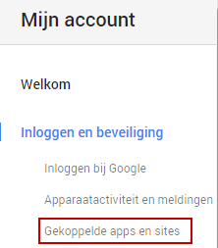
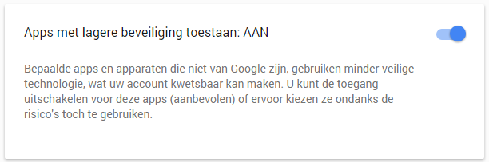
AAN
Now you can use this to send you an email if the server reboots or whatever you want!
crontab -l
@reboot
Example: http://askubuntu.com/questions/399223/crontab-entry-to-reboot-than-email

- Configure Telenet Router

Well, all of this is working from your home network. There are still some things you can do to make this available worldwide. But for this, we have to reconfigure our Telenet router a little. Sorry for the guys with Belgacom or others, I have no clue what you can do. I guess it will be kind off the same for you.

Find out your routers IP.
Go to https://mijn.telenet.be

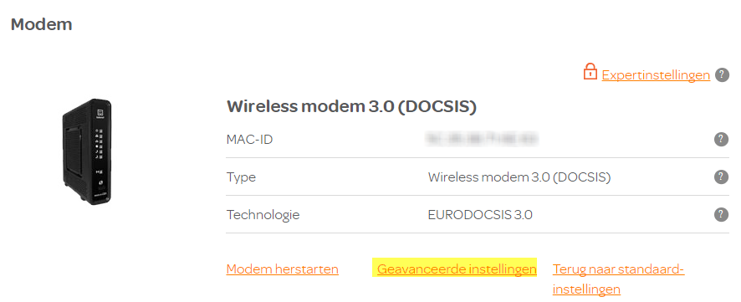

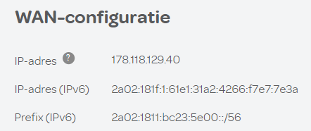

Setup Port Forwarding.

Steeds bij geavanceerde instellingen:

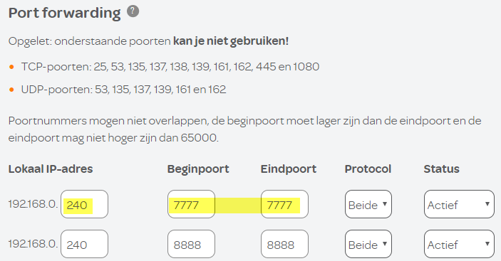

IP address of the server where SSH / transmission / sickrage is running.
Incoming port of telenet router does not have to be the same as the one on your backend server!

Connect from anywhere.

